**Create a New Chat on Microsoft Teams:**

This can be used to message one or many individuals directly.

1. Open Microsoft Teams and observe the tabs on left panel. Click on Chat. 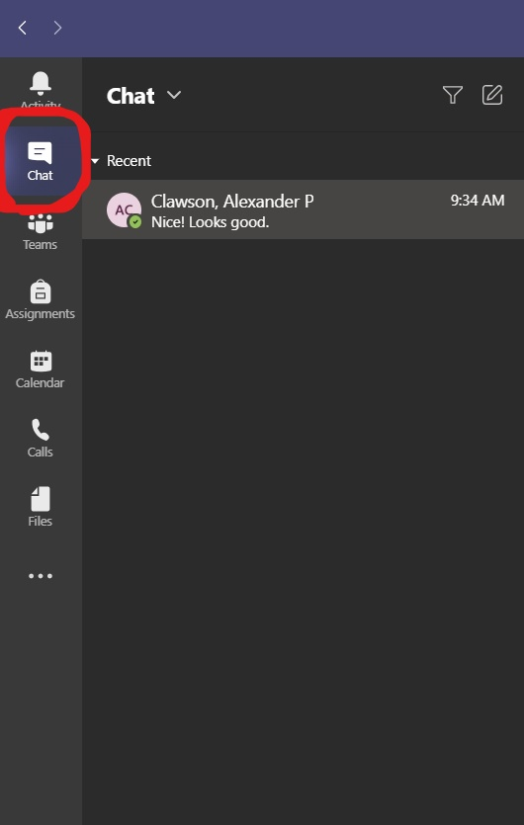
2. This will bring you to the chat screen. Click on the Create New button. 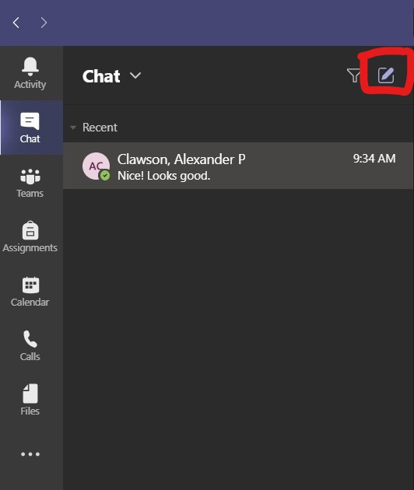
3. This will open the chat screen. Enter a name, email, or group/tag and press Enter. If logged in with NECC account, Microsoft Teams will show contacts from NECC account. Groups and tags are created and work only within Microsoft teams. 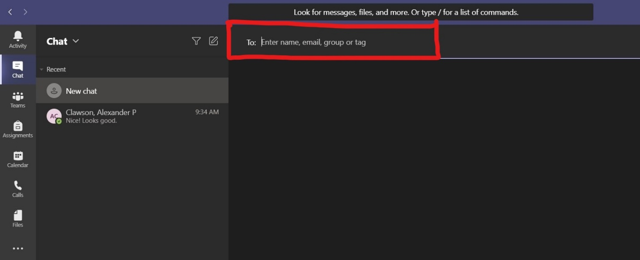
4. Once you compose the message, click on the send button or press Enter. 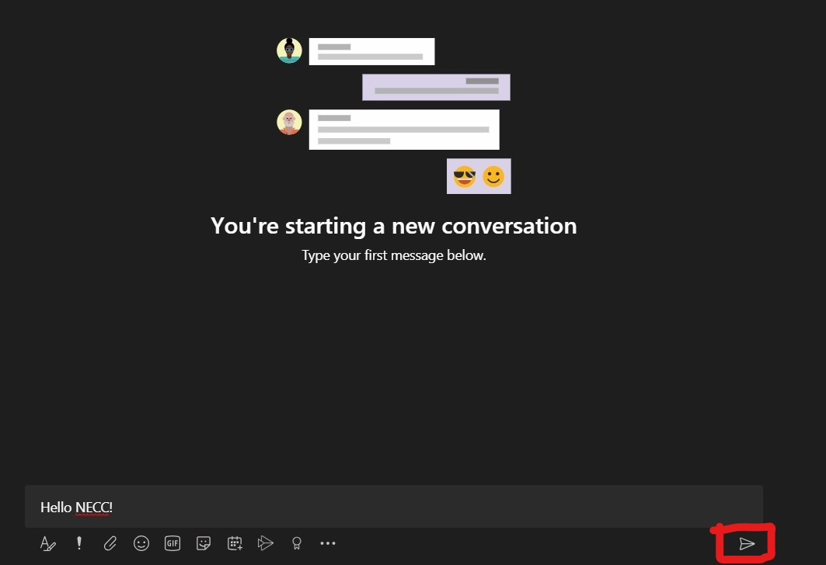

**Tips:**

* Press **Ctrl+N** to compose a new chat from anywhere in Microsoft Teams.
* Attach a file from your computer and send it along with your message using the Attach button. 